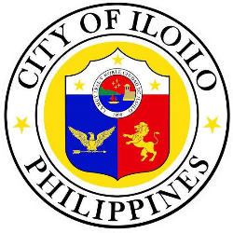
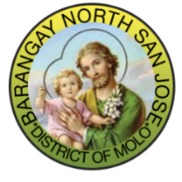
REPUBLIC OF THE PHILIPPINES
CITY OF ILOILO
DISTRICT OF MOLO
BARANGAY NORTH SAN JOSE
OFFICE OF THE PUNONG BARANGAY

_______________________________

_______________________________

_______________________________

Sir/Madaam:

Greetings!

On March 17-19 our Barangay will be celebrating our patronal fiesta in honor of Senior San Jose. We are in the belief that an earlier preparation is important to ensure that everything that is needed to provide a memorable and enjoyable fiesta is well taken care of.

In line with this, we are knocking on your generous heart to support our Fiesta Celebration through financial assistance or sponsorship of the materials needed. Any amount is highly appreciated.

We are inviting you also to join with us in our Opening Salvo “Parade of Sponsors” on March 17, 2024.

We sincerely cherish your kind support on our endeavors. Thank you and God Bless!

Very Truly Yours,

HON. TERESITA C. ABONG
PUNONG BARANGAY

